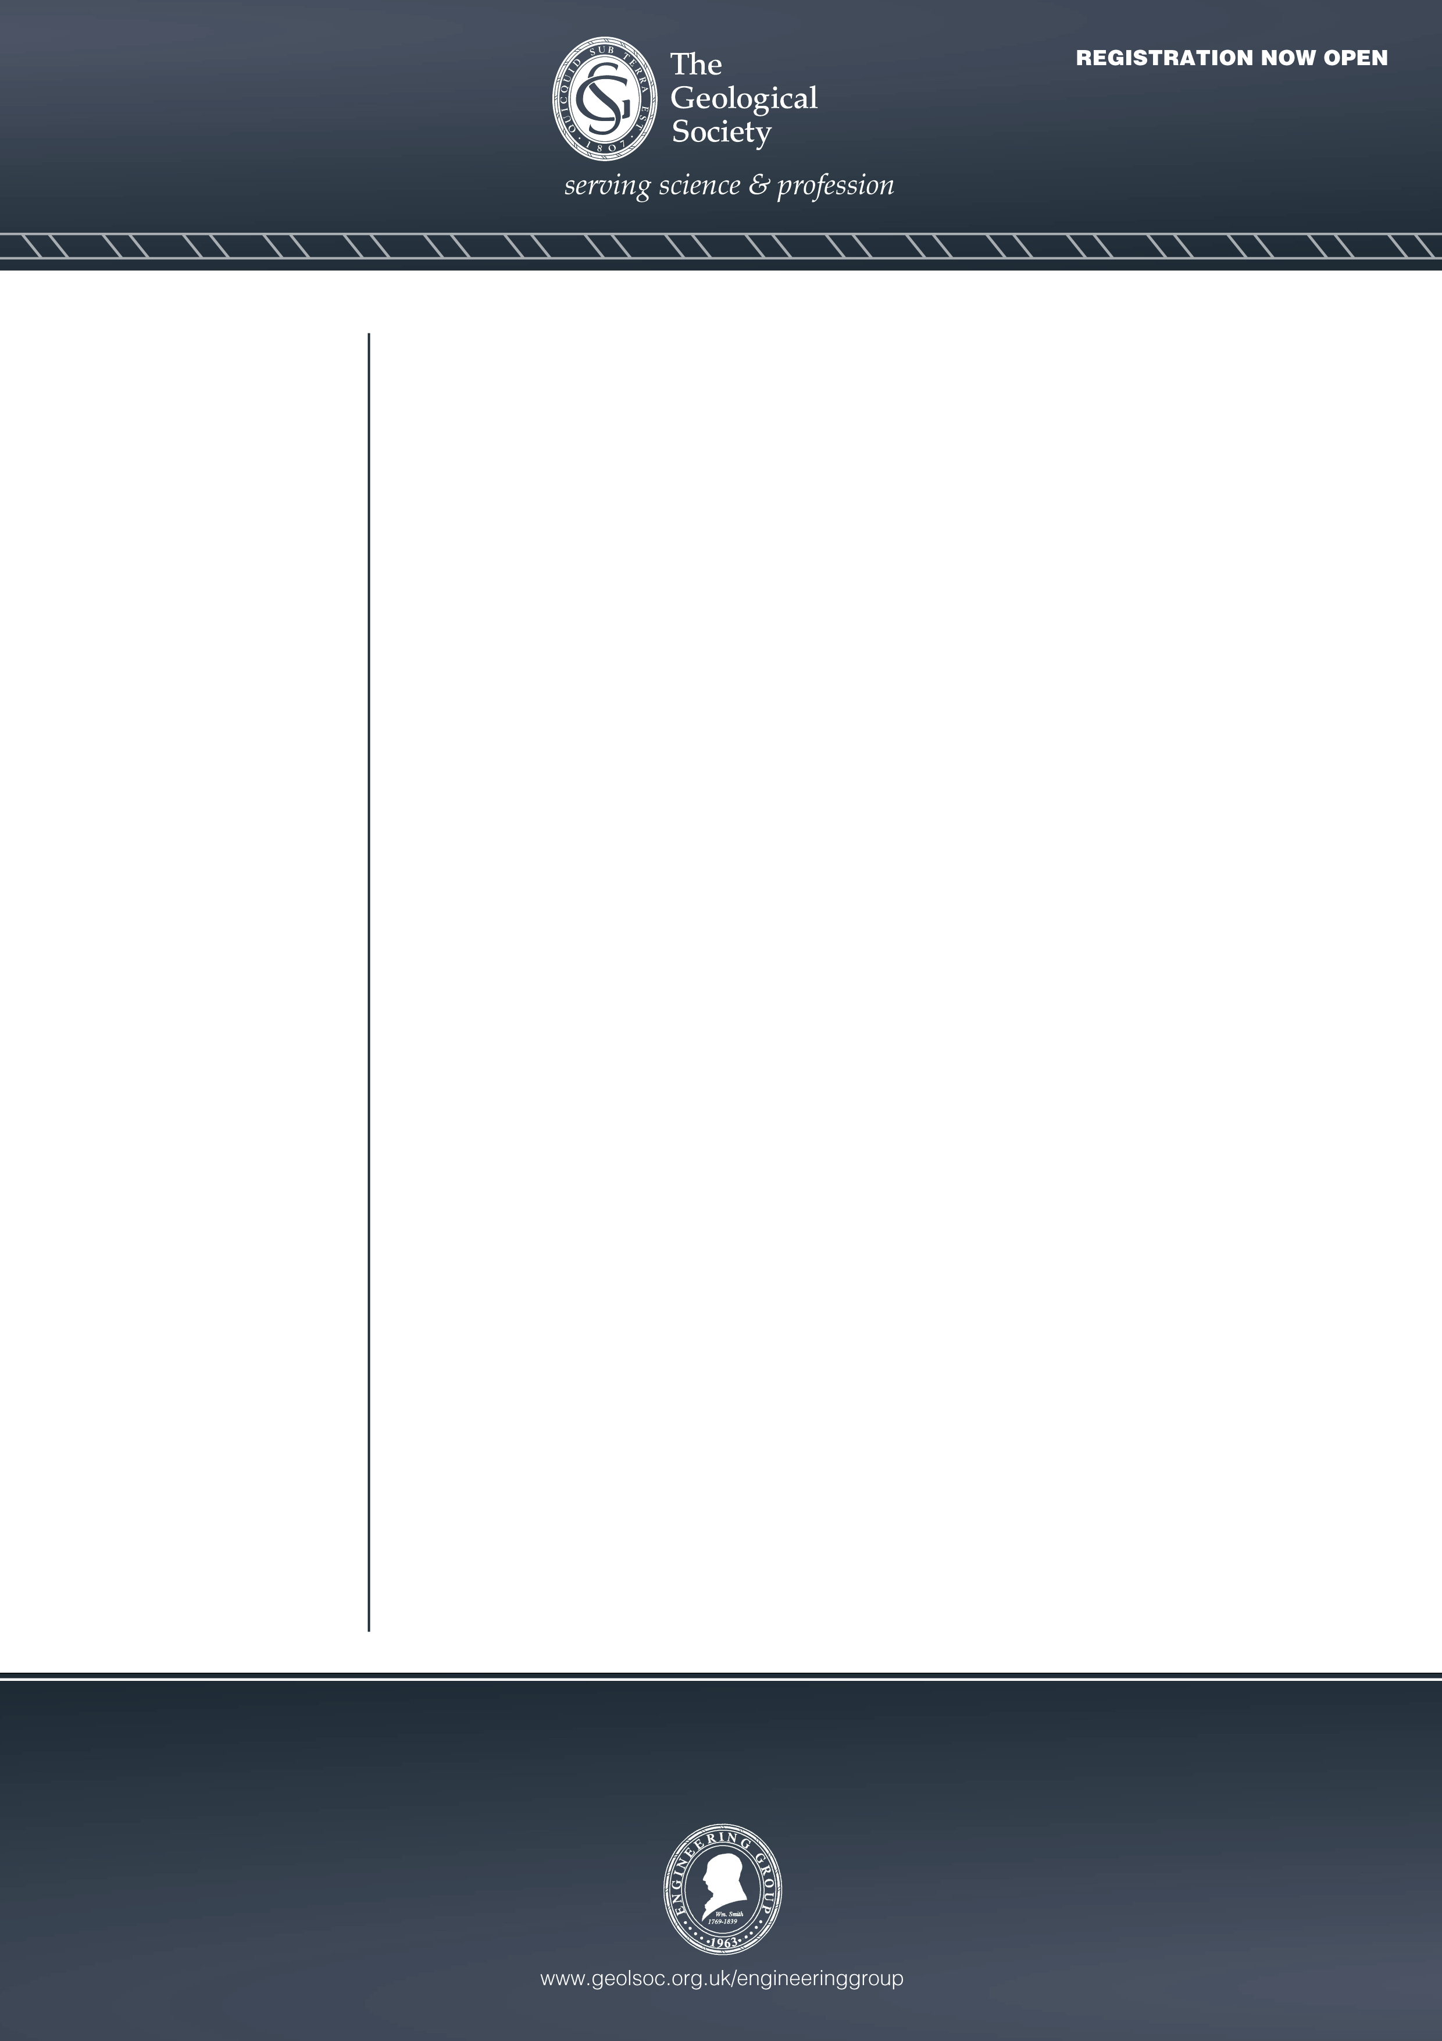


Speaker:

Jeremy Ingham
Diales

Date:
Wednesday 3rd February 2021

Meeting Commences:
18:00

Location:
Geomaterials Practitioner Meeting link
Please note the event will be broadcast live:

Free to attend. Registration not required.

Event convener: Dr Ursula Lawrence (Ursula.Lawrence@capita.co.uk)

Full details also available here: https://www.britishgeotech.org/events/278-joint-bga-eggs-meeting-3-february-2021

The Geomaterials Practitioner

A Joint evening meeting by the Engineering Group of the Geological Society (EGGS) and British Geotechnical Association
Synopsis
Geomaterials are geologically-derived materials used in the construction of buildings and civil engineering structures. Common types include building stone, bricks, roadstone, construction fill, cement, concrete, mortar and plaster. These materials are essential to the construction industry and of huge value to the global economy.

Materials engineers are an essential part of construction and civil engineering project teams. They use their knowledge of geology, civil engineering and materials science to improve the quality of our built environment by helping to ensure that construction materials are suitable for their intended purpose and correctly used. They may also apply their knowledge of the properties and performance of geomaterials to investigate the condition of structures during service, determine the cause of failures, specify repairs and conserve historic buildings. Experienced geomaterials practitioners may be called upon to act as an expert witness in cases of dispute.

This talk provides an introduction the world of the industrial geomaterials practitioner and the expert witness. It will discuss lessons learnt from a review of over one hundred forensic engineering investigations of defects and failures involving geomaterials. Failures were observed to result from deficient design, inadequate workmanship or defective materials and, frequently, from a combination of issues. Examples based on the case studies will be presented with the aim of improving future design and construction practice.

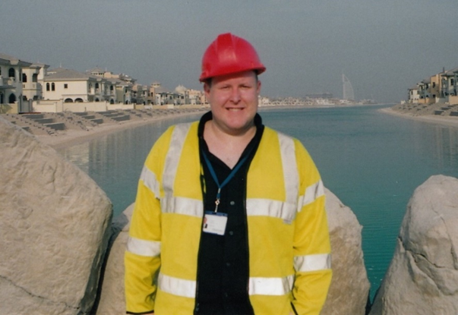

Jeremy is a Technical Director at Diales where he provides expert witness services to the global engineering and construction industry. As a geomaterials specialist he has been providing advice regarding construction materials for over twenty-five years. After attaining a BSc in Geology and MSc in Geomaterials at the University of London, he spent twelve years working for construction materials testing companies, before going on to work for engineering consultants Halcrow, Mott MacDonald and Capita Property and Infrastructure. He has a keen interest in forensic engineering and for the last five years has spent most of his time undertaking expert witness commissions involving allegedly defective or inappropriately used building materials. He is also the author of the geomaterials text book entitled ‘Geomaterials Under the Microscope: a Colour Guide’

